**Steps for WooCommerce Transactional Emails –**

1. Download and activate ‘WP Mail SMTP’ plugin
2. Under WP Mail SMTP 🡪 settings, select mailer for email and fill required fields
3. Please refer below image

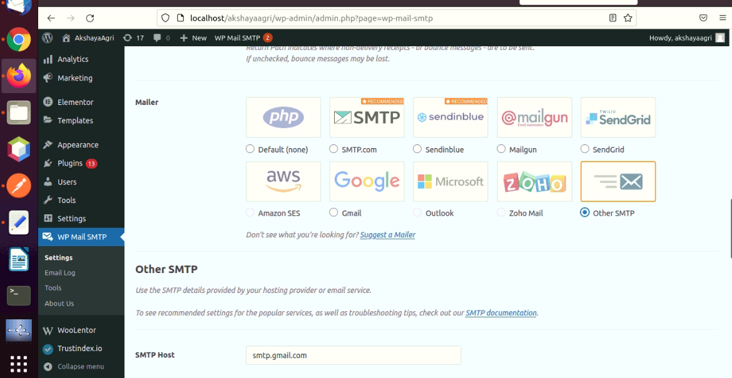

1. Now under WooCommerce 🡪 settings 🡪click ‘Emails’, you will find Email notifications sent from WooCommerce which are –

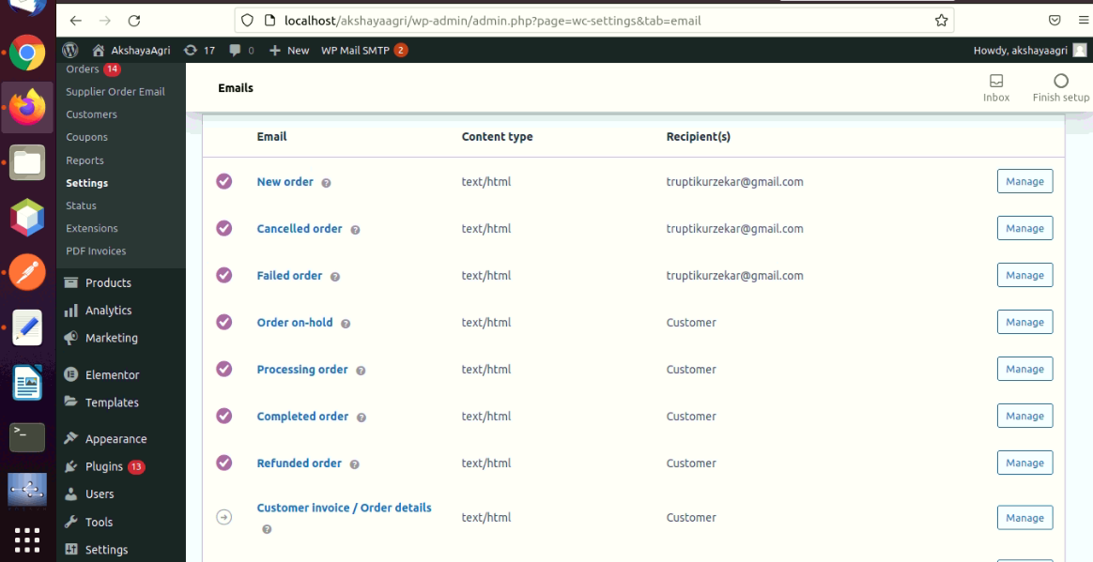

1. To make changes in email template click on Manage button for specific email under which you can make changes.

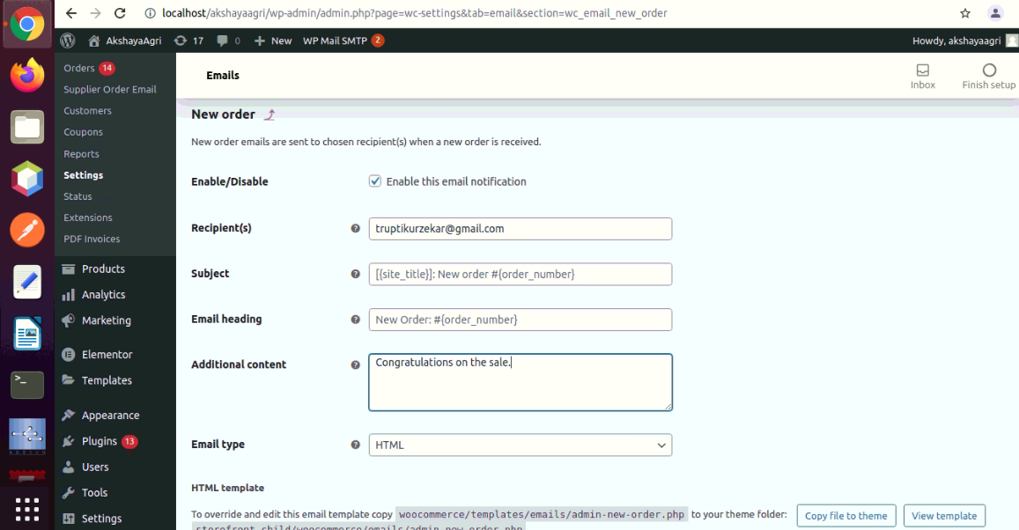

1. To customize email template you can also use ‘hook’ which can be placed in functions.php file.
2. To add custom field to email template we need to make changes in WooCommerce /templates/emails/filename. So instead of editing core file we will copy that file to child_theme/woocommerce/emails/filename.
3. Suppose we have to make changes in New Order email template then we will go to woocommerce/templates/emails/ and will copy admin-new-order.php file and paste that file to child_theme/woocommerce/emails/ and here we will make changes as suppose any update will come it won’t affect our changes.
4. If custom field is not added then we also need to add custom field and will add code for it in functions.php file

